Arrays
_____________________________________________________________________________________
Q. What is array?
_____________________________________________________________________________________
Array is a collection of similar type of data, or it is used for store multiple values in single variable called as array.

How to declare array in JAVA
_____________________________________________________________________________________
If we want to declare array in java we have two steps.
1. Declare array: if we want to declare array, we have to use following syntax
Syntax: data type variablename[]; //declaration.
When we declare array in java then array not allocate its memory just create reference variable which is used for storing the address of array or store base address of array and by default array reference variable is null.

2. Allocate memory of array: if we have to allocate memory in array, we need to use new keyword means when we use new keyword then array variable allocates memory and store 0th location address in reference variable.
Syntax: variablename = new datatype[size];
Example: int a[]; //reference variable of array
a = new int[5];
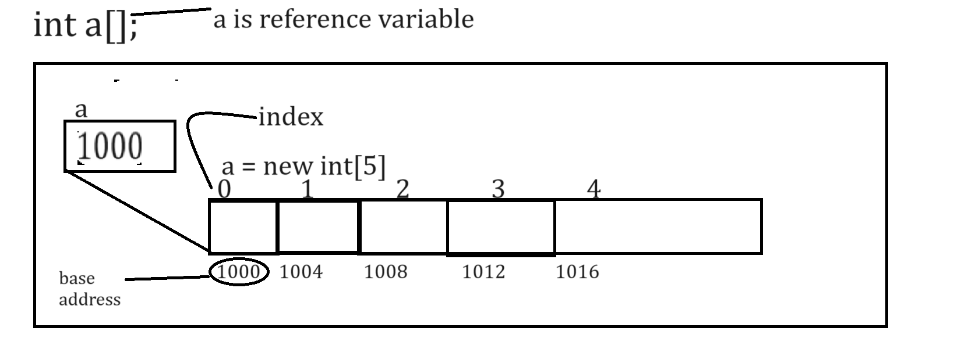
Note: if we think about above memory diagram we have assume or consider 1000 is our base address and 0, 1,2,3,4 these are indexes.

Q. What is base address?
_____________________________________________________________________________________
0th index address called as base address.

Q. What is index and why use index?
Index is identity of block in array or value in array and it is used for insert data in array, delete data from array or update data in array or search data from array etc
Note: Array index always start from 0th index.
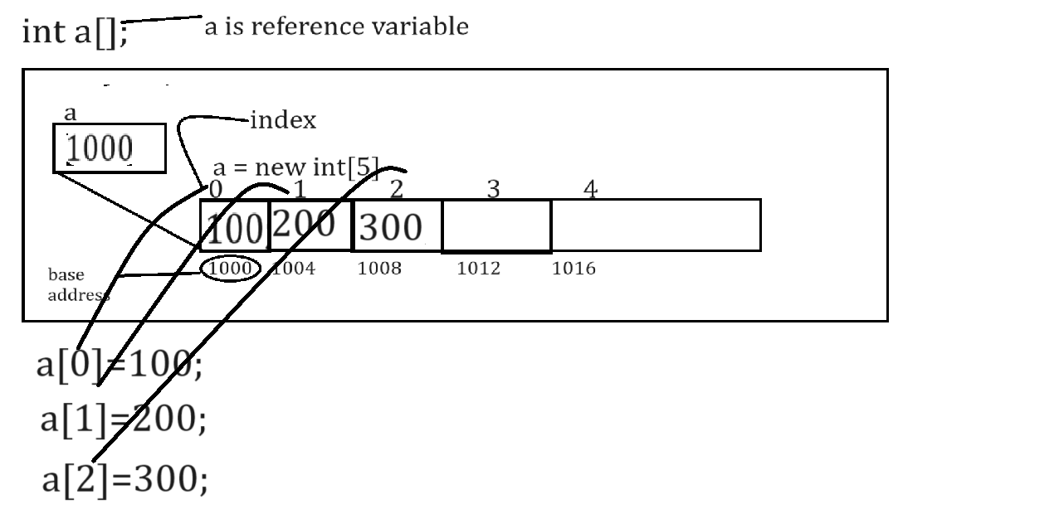
Note: If we think about above diagram, we store element manually on every index but if we have array size of 100 then we need to write 100 different individual lines of code and it is not possible in real time so better way you can use loop for store data in array or retrieve data from array or perform any other operation on array.
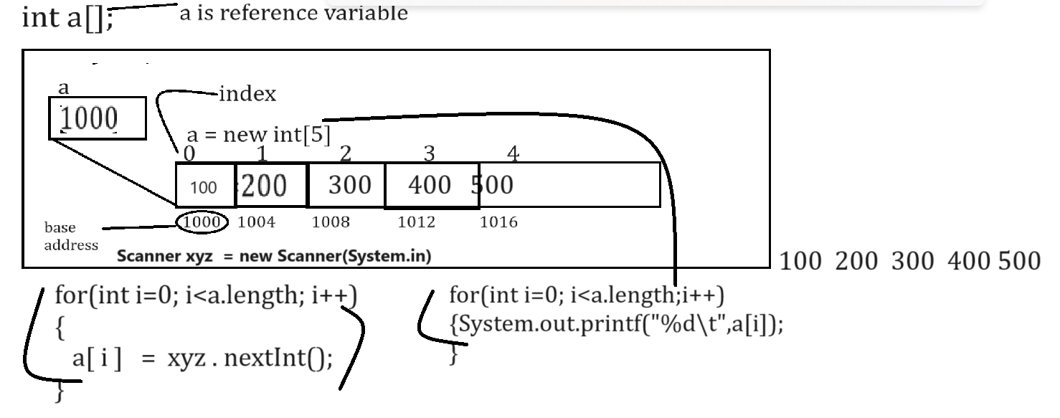
Note: length is constant of array in JAVA which help us to return the size of array
Example with source code
import java.util.*;
public class ArrayApp
{ public static void main(String x[])
{ int a[];//declaration or reference variable of array
a = new int[5];//allocated memory for array.
Scanner xyz = new Scanner(System.in);
System.out.println("Enter values in array");
for(int i=0; i<(a.length-1); i++)
{
a[i]=xyz.nextInt();//store values in array
}
System.out.println("Display array values");
for(int i=0;i<a.length;i++)
{ System.out.printf("%d\t",a[i]);
}
}
}
Note: If we think about above code we can say int a[] is reference variable means it contain address of 0th location
2. When we declare array variable then its default value is null
Q. Can we prove default value of array is null?
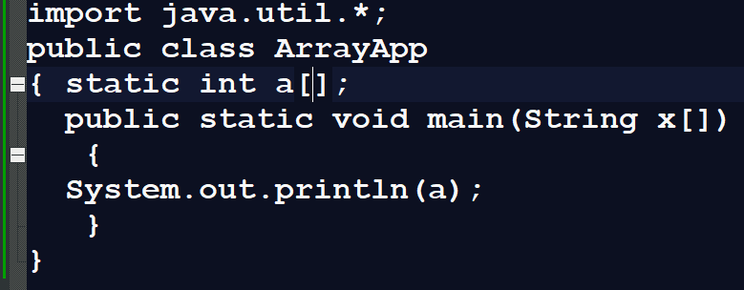
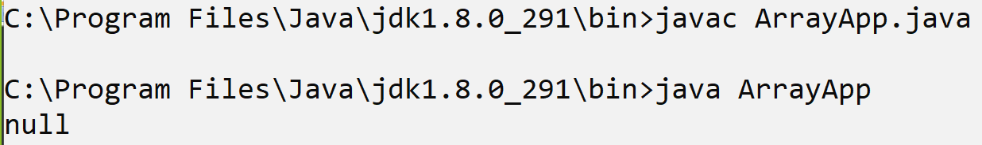
Note: If we think about above code we use array without new keyword then we get its default value null. Null means variable not points to address in memory.

Q. What happen if we use array without using new keyword?
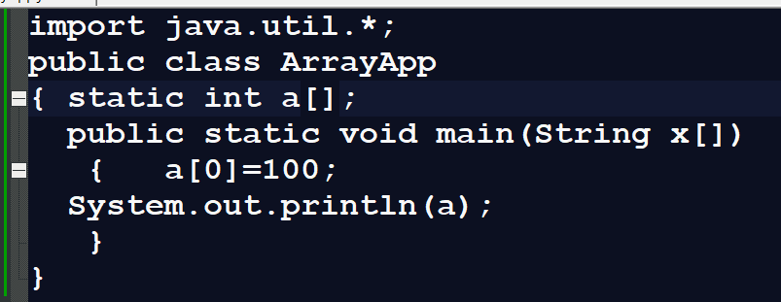
Note: if we use array without using new keyword then we get NullPointerException error at program run time because if we want to store value in memory, we must have some space or address but if we not use new keyword then there is no memory present so we cannot store values and if we try then we get run time error NullPointerException.

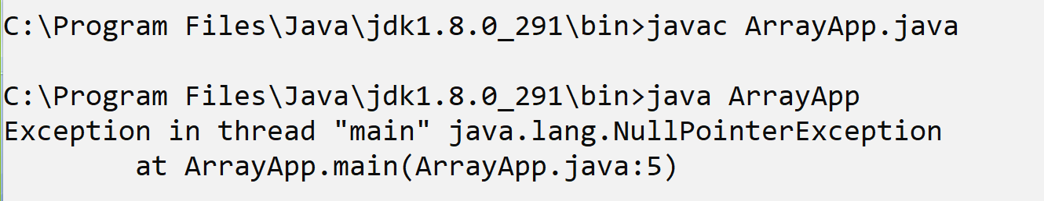
Q. Can we see the address present in reference variable or array variable?
_____________________________________________________________________________________
Yes, we can see the address of reference variable and for that we have System.identityHashCode() method

import java.util.*;
public class ArrayApp
{ static int a[];
public static void main(String x[])
{
a= new int[5];
System.out.println("Base address of array is "+System.identityHashCode(a));
}
}
Output
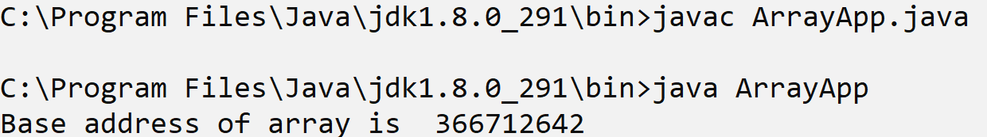

How to initialize array with fix values in JAVA?
_____________________________________________________________________________________
If we want to initialize array with fix values in java we have following syntax
Syntax: int a[]={value1,value2……value…n};
import java.util.*;
public class ArrayApp
{
public static void main(String x[])
{
int a[]={10,20,30,40,50};
System.out.println("Display array values");
for(int i=0;i<a.length;i++)
{ System.out.printf("%d\t",a[i]);
}
}
}
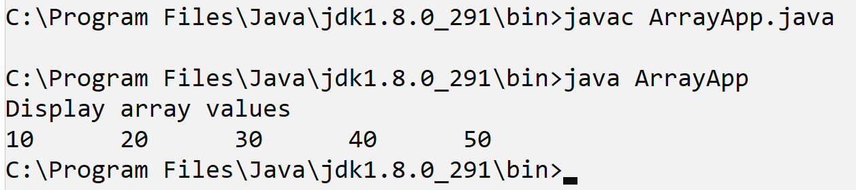
or
int a[]=new int[]{value1,value2…..value…n};

Example with source code
import java.util.*;
public class ArrayApp
{ public static void main(String x[])
{ int a[]=new int[]{10,20,30,40,50};
System.out.println("Display array values");
for(int i=0;i<a.length;i++)
{ System.out.printf("%d\t",a[i]);
}
}
}
Output
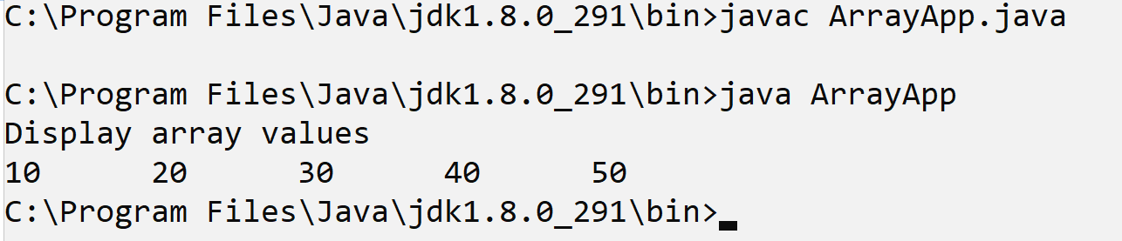
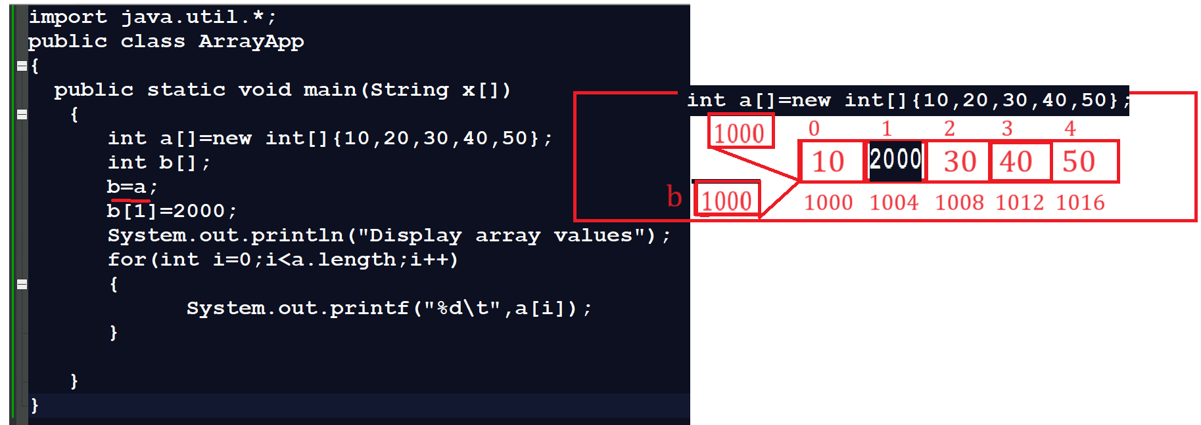
Assignments
________________________________________________________________________
Q1. WAP to create array of size 5 and find the max and min value from array?
Q2. WAP to create array of size 5 and input single value from keyboard and search value present in array or not?
Q3. WAP to create array of size 5 and reverse it means shift value of its index?
Q4. WAP to create array of size 5 and arrange all in ascending and descending order?
Q5. WAP to create array of size 5 and calculate sum of all values.
Example: 10 20 30 40 50 = 150

Array Declaration ways
_____________________________________________________________________________________
Syntax: datatype variablename[]; : this syntax help us to declare specific variable as array.
or
datatype []variablename: this syntax help us to declare all variable as array in that particular statement.
Example:
int a[],b,c,d[]; here a and d are array variable and b, c is normal variable
Means when we want to declare specific variable as array then we can use this approach.
Or
int []a,b,c,d; all four variables are array variable.
Means when we want to declare more than one variable as array of same type then we can use this approach

Example:
public class ArrayApp
{
public static void main(String x[])
{
int []a={10,20,30,40,50};
System.out.println("display array");
for(int i=0;i<a.length;i++)
{
System.out.printf("%d\t",a[i]);
}
}
}

Two dimensional arrays in JAVA
_____________________________________________________________________________________
Two-dimensional array is used for create the matrix but it is not matrix internally it is sequential block of memory and every block has two digit index.
Syntax of declare two-dimensional array
1. datatype variablename[][];
or
datatype[][] variablename;
or
datatype[] variablename[];
Example:
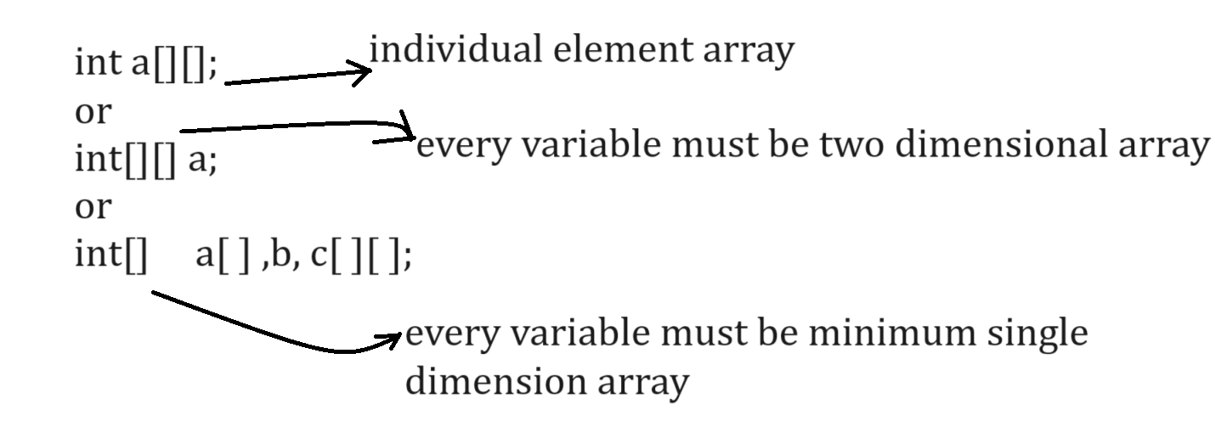

How two-dimensional arrays stored in memory
_____________________________________________________________________________________
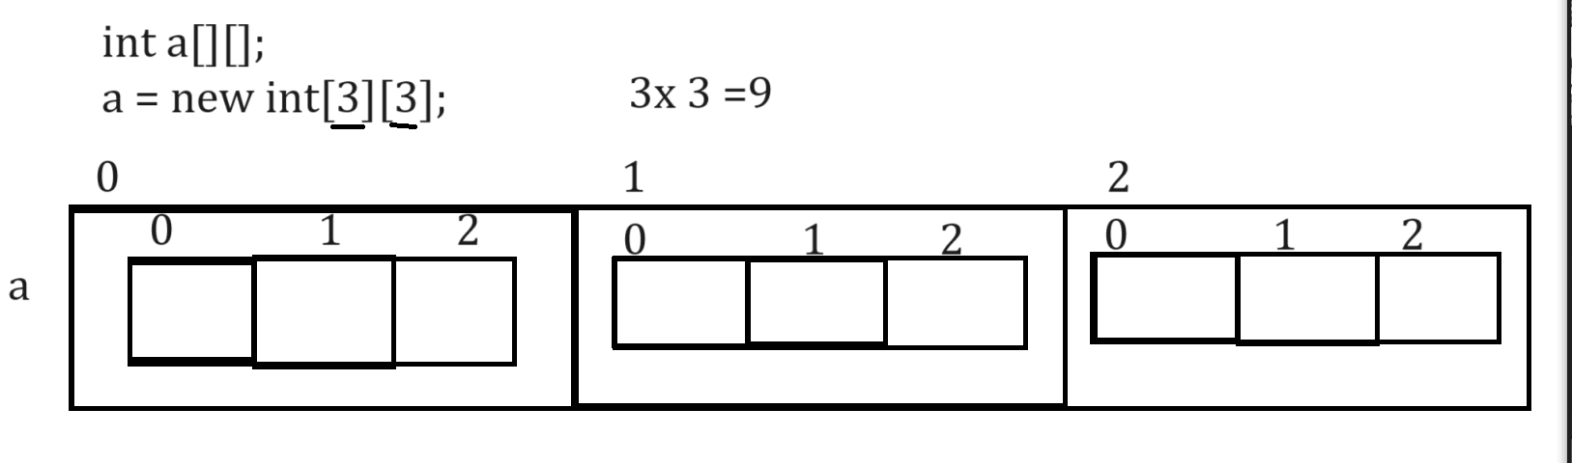
Example with source code
public class ArrayApp
{ public static void main(String []x)
{ int a[][]=new int[3][3];
System.out.println("Size of a[0] "+a[0].length);
System.out.println("Size of a[1] "+a[1].length);
System.out.println("Size of a[2] "+a[2].length);
System.out.println("total size of a "+(a[0].length+a[1].length+a[2].length));
}
}
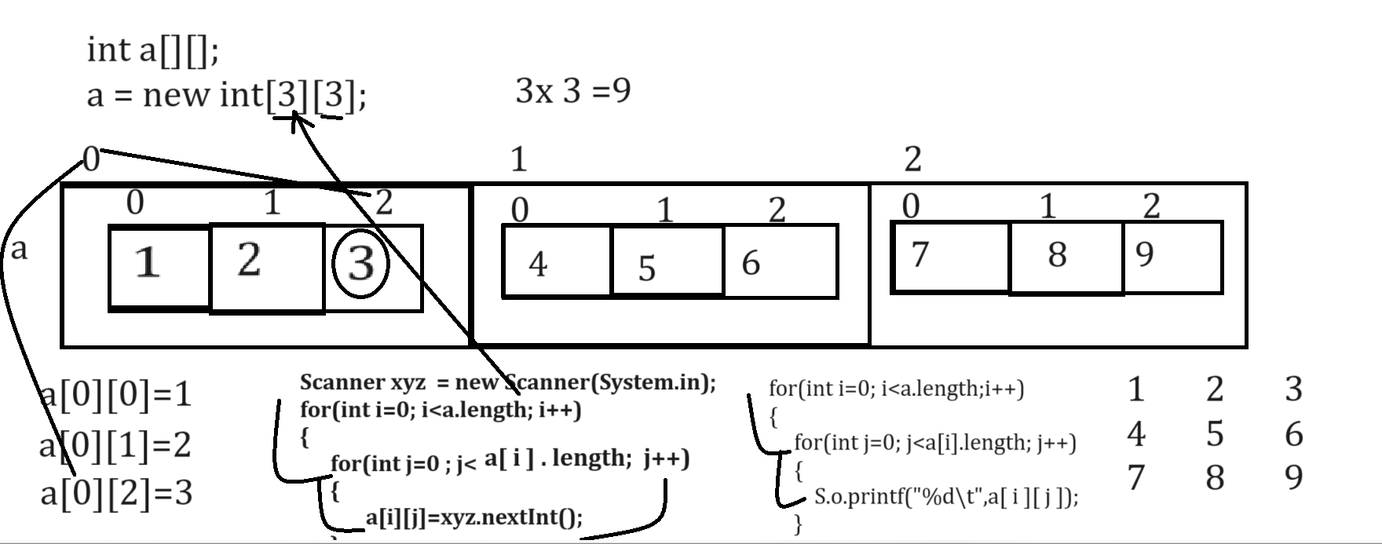
Example with source code
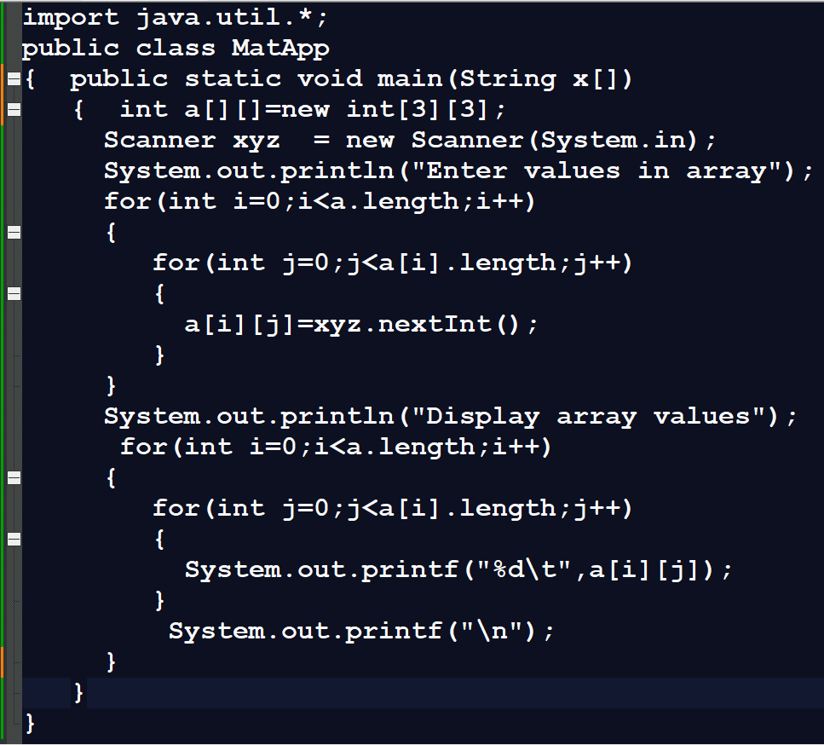
Output
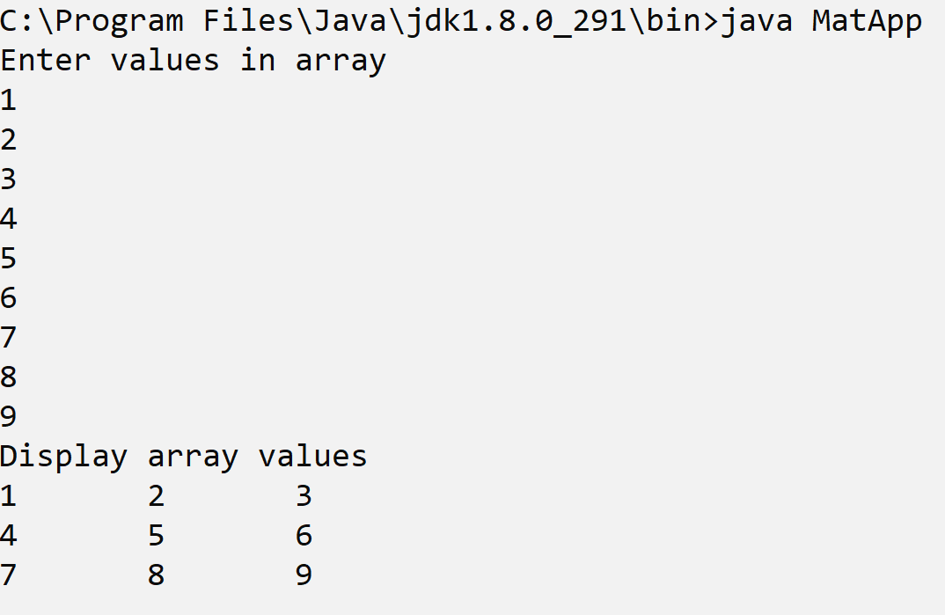
Jagged Array
_____________________________________________________________________________________
Jagged Array is facility in Java where we can create matrix every row having different column list.

How to use Jagged Array Practically
_____________________________________________________________________________________
Syntax:
datatype variablename[][] = new datatype[row][];
a[rowindex]=new datatype[colsize];
Example: we want to create matrix like as
1 2 3
4 5 6 7
8 9
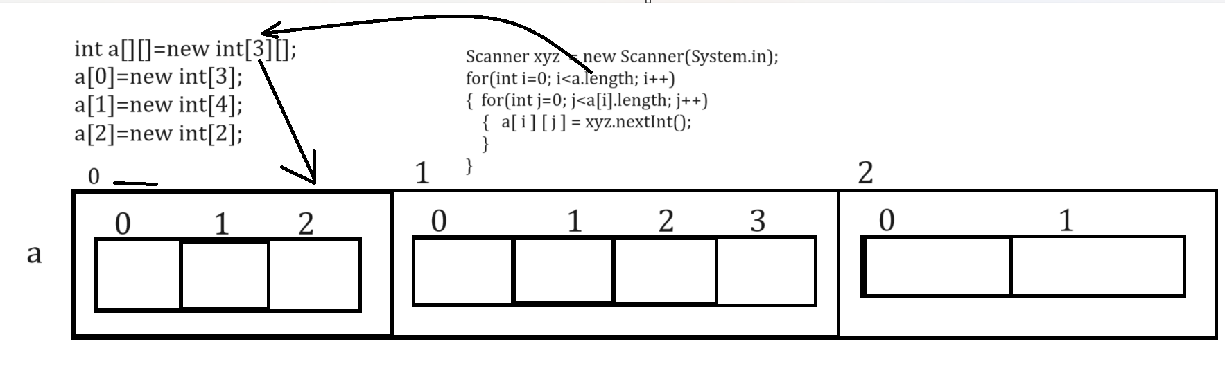
Example with source code
import java.util.*;
public class MatApp
{ public static void main(String x[])
{ int a[][]=new int[3][];
a[0]=new int[3];
a[1]=new int[4];
a[2]=new int[2];
Scanner xyz = new Scanner(System.in);
System.out.println("Enter values in array");
for(int i=0;i<a.length;i++)
{
for(int j=0;j<a[i].length;j++)
{
a[i][j]=xyz.nextInt();
}
}
System.out.println("Display array values");
for(int i=0;i<a.length;i++)
{
for(int j=0;j<a[i].length;j++)
{
System.out.printf("%d\t",a[i][j]);
}
System.out.printf("\n");
}
}
}
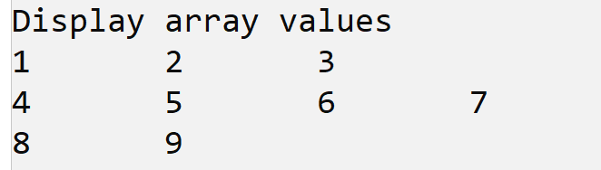

How to initialize two dimensional arrays in JAVA
_____________________________________________________________________________________
Initialization means to fix the values in array called as initialization
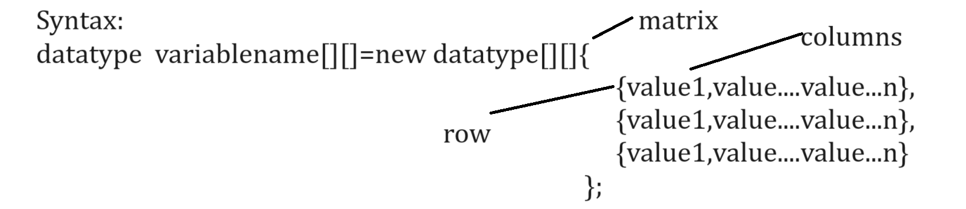
Example with source code
import java.util.*;
public class MatApp
{ public static void main(String x[])
{ int a[][]=new int[][]{
{1,2,3},
{4,5,6},
{7,8,9}
};
System.out.println("Display array values");
for(int i=0;i<a.length;i++)
{
for(int j=0;j<a[i].length;j++)
{
System.out.printf("%d\t",a[i][j]);
}
System.out.printf("\n");
}
}
}
Output
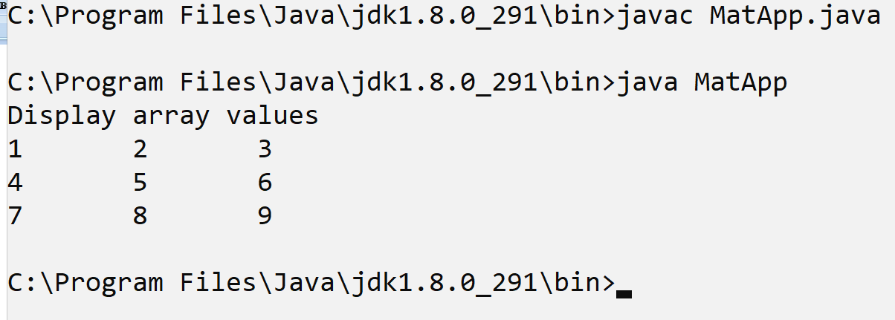
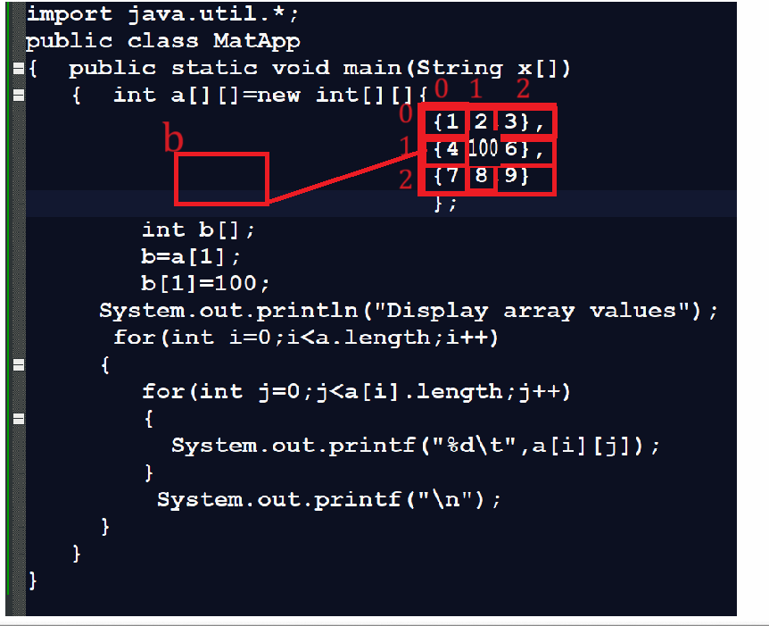

Example: WAP to input five values in array and arrange in ascending order.
_____________________________________________________________________________________
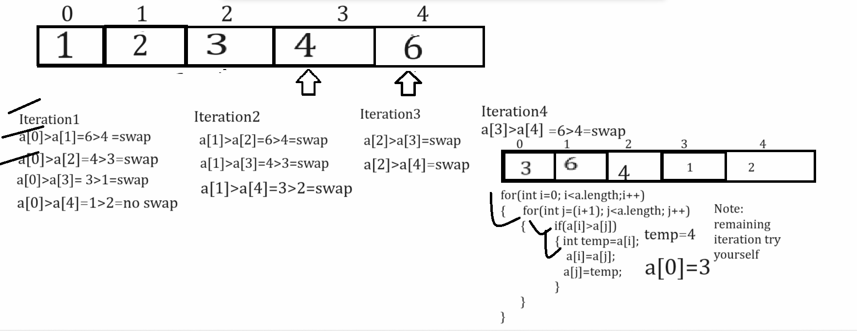
Example with source code
import java.util.*;
public class AscendingApp
{
public static void main(String x[])
{
Scanner xyz = new Scanner(System.in);
int a[]=new int[5];
System.out.println("Enter values in array");
for(int i=0;i<a.length;i++)
{ a[i]=xyz.nextInt();
}
System.out.println("Display array before sorting");
for(int i=0;i<a.length;i++)
{ System.out.printf("%d\t",a[i]);
}
//apply ascending order logics
for(int i=0;i<a.length;i++)
{ for(int j=(i+1);j<a.length;j++)
{
if(a[i]>a[j])
{ int temp=a[i];
a[i]=a[j];
a[j]=temp;
}
}
} System.out.printf("\n\n");
System.out.println("Display array values after sorting ");
for(int i=0;i<a.length;i++)
{ System.out.printf("%d\t",a[i]);
}
}
}
Output
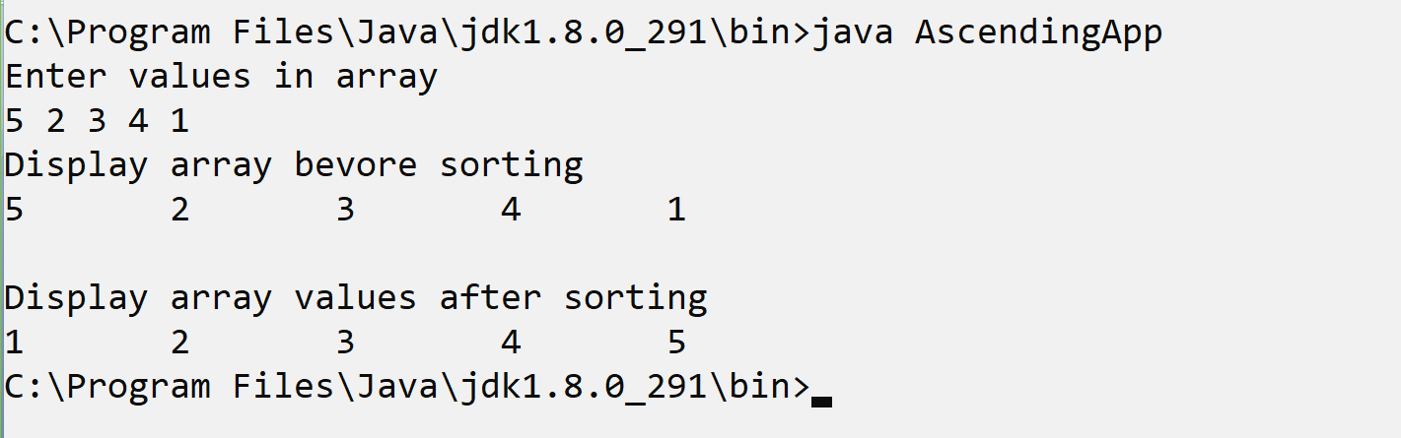

Example: WAP to create array and find second highest value with sorting and without using sorting
___________________________________________________________________________________
Finding second highest value using sorting technique
import java.util.*;
public class AscendingApp
{ public static void main(String x[])
{ Scanner xyz = new Scanner(System.in);
int a[]=new int[5];
System.out.println("Enter values in array");
for(int i=0;i<a.length;i++)
{ a[i]=xyz.nextInt();
}
System.out.println("Display array before sorting");
for(int i=0;i<a.length;i++)
{ System.out.printf("%d\t",a[i]);
}
//apply ascending order logics
for(int i=0;i<a.length;i++)
{ for(int j=(i+1);j<a.length;j++)
{ if(a[i]>a[j])
{ int temp=a[i];
a[i]=a[j];
a[j]=temp;
}
}
} System.out.printf("\n\n");
System.out.println("Display array values after sorting ");
for(int i=0;i<a.length;i++)
{ System.out.printf("%d\t",a[i]);
}
int count=0;
for(int i=0;i<a.length; i++)
{ if(a[a.length-1]==a[i])
{ ++count;
}
}
System.out.println("Second highest value of array is "+a[a.length-(count+1)]);
}
}
Finding second highest value without using sorting technique
_____________________________________________________________________________________
Note: before finding second highest value first we want to find the highest from array without using sorting and after that we can work logic of second highest
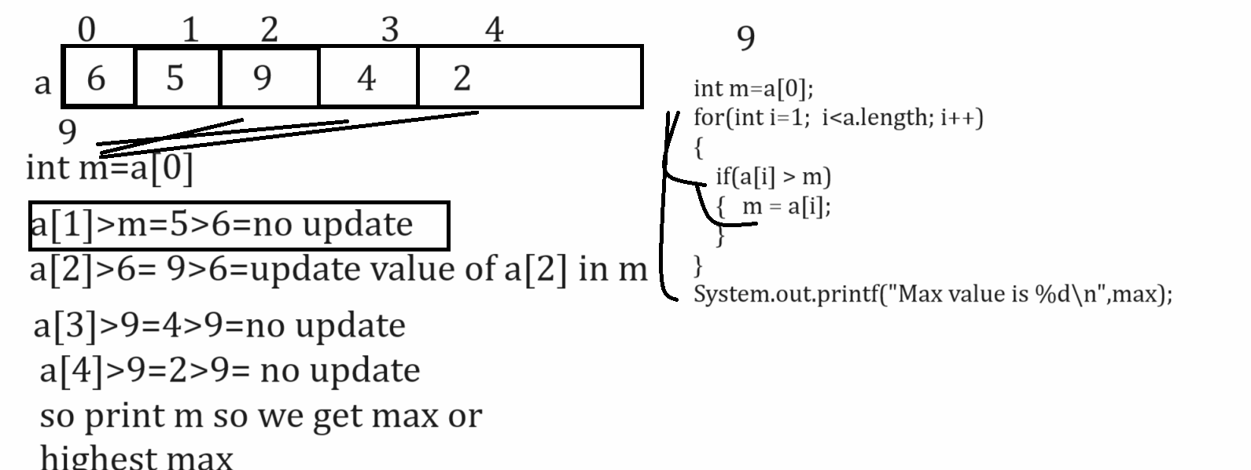
Example with source code
import java.util.*;
public class FindingMaxApp
{
public static void main(String []x)
{
Scanner xyz = new Scanner(System.in);
int a[]=new int[5];
System.out.println("Enter values in array");
for(int i=0;i<a.length;i++)
{
a[i]=xyz.nextInt();
}
int m=a[0];
for(int i=1; i<a.length; i++)
{
if(a[i]>m)
{ m=a[i];
}
}
System.out.printf("Max value is %d\n",m);
}
}

Example: WAP to find the missing elements from sorted array
_____________________________________________________________________________________
Input: 1 5 9 12 15
Output: 2 3 4 6 7 8 10 11 13 14

import java.util.*;
public class FindMSL
{
public static void main(String x[])
{
int a[]=new int[5];
Scanner xyz = new Scanner(System.in);
System.out.println("Enter values in array");
for(int i=0; i<a.length;i++)
{ a[i]=xyz.nextInt();
}
System.out.println("Display original array");
for(int i=0; i<a.length;i++)
{ System.out.printf("%d\t",a[i]);
}
//find missing logics
/*for(int i=0;i<(a.length-1);i++)
{
int diff=a[i+1]-a[i];
if(diff>1)
{ int count=a[i];
while(count<(a[i+1]-1))
{ ++count;
System.out.printf("%d\t",count);
}
}
}*/
System.out.println("\nDissing elements of array\n");
for(int i=0; i<(a.length-1); i++)
{
for(int j=a[i];j<(a[i+1]-1);)
{
System.out.printf("%d\t",++j);
}
}
}
}
Example: WAP to create array of size and print Fibonacci series using array.
0 1 1 2 3 5 8
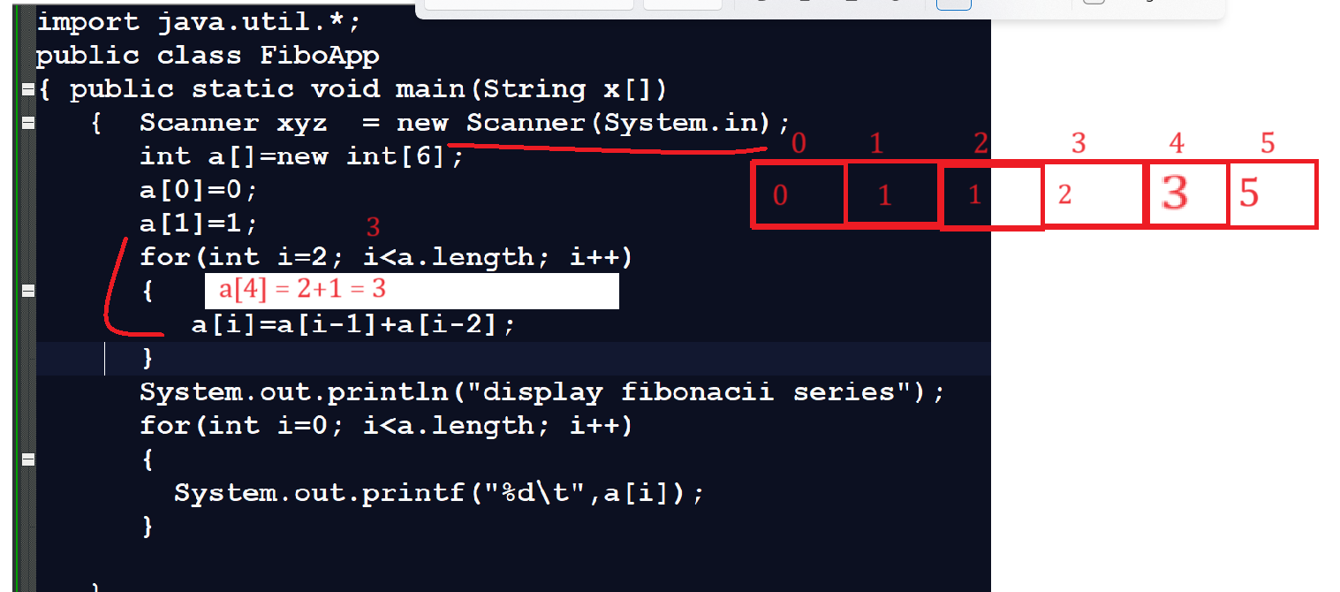

Example: WAP to create two array of size 5 and 5 and merge them in third array and third array size is 10
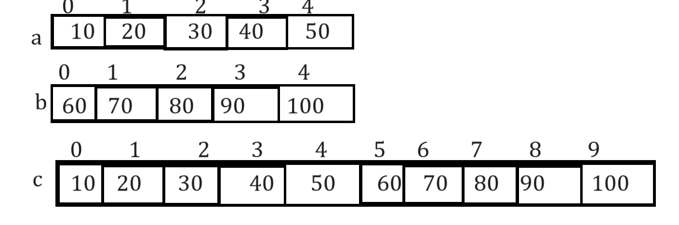

Example:
import java.util.*;
public class TestArr
{ public static void main(String x[])
{ int a[]=new int[5];
int b[]=new int[5];
int c[]=new int[10];
Scanner xyz = new Scanner(System.in);
System.out.println("Enter five values in array");
for(int i=0; i<a.length; i++)
{ a[i]=xyz.nextInt();
}
System.out.println("Enter five values in second array");
for(int i=0;i<a.length;i++)
{ b[i]=xyz.nextInt();
}
int k=0;
for(int i=0;i<a.length;i++,k++)
{ c[i]=a[i];
}
for(int j=0;j<b.length;j++)
{ c[k]=b[j];
k++;
}
System.out.println("Array after merging");
for(int i=0;i<c.length;i++)
{ System.out.printf("%d\t",c[i]);
}
}
}

Example: WAP to create 3 x 3 matrices and calculate the sum of row
import java.util.*;
public class TwoDArrayApp
{
public static void main(String x[])
{ Scanner xyz = new Scanner(System.in);
int a[][]=new int[3][3];
System.out.println("enter 3 x 3 matrix\n");
for(int i=0; i<a.length; i++)
{
for(int j=0; j<a[i].length; j++)
{
a[i][j]=xyz.nextInt();
}
}
System.out.println("display all values");
for(int i=0; i<a.length; i++)
{ int sum=0;
for(int j=0; j<a[i].length; j++)
{ System.out.printf("%d\t",a[i][j]);
sum = sum +a[i][j];
}
System.out.printf(" = %d\n",sum);
}
}
}
Output
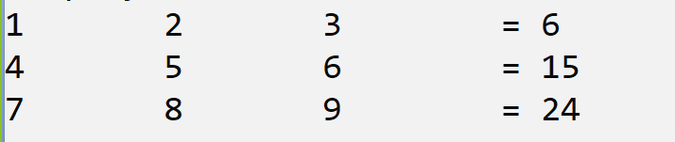

Example: WAP to create 3 x 3 matrixes and calculate the sum of left and right diagonal of element.
import java.util.*;
public class TwoDArrayApp
{
public static void main(String x[])
{ Scanner xyz = new Scanner(System.in);
int a[][]=new int[3][3];
int lsum=0,rsum=0;
System.out.println("enter 3 x 3 matrix\n");
for(int i=0; i<a.length; i++)
{
for(int j=0; j<a[i].length; j++)
{
a[i][j]=xyz.nextInt();
}
}
System.out.println("display all values");
for(int i=0; i<a.length; i++)
{
for(int j=0; j<a[i].length; j++)
{ System.out.printf("%d\t",a[i][j]);
if(i==j)
{ lsum=lsum+a[i][j];
}
if(j==2-i)
{ rsum=rsum+a[i][j];
}
}
System.out.printf("\n");

}
System.out.printf("Sum of left diagonal is %d\n",lsum);
System.out.printf("Sum of right diagonal is %d\n",rsum);
}
}

Time Complexity and Big O notations
_____________________________________________________________________________________
Q. Why learn Time Complexity?
_____________________________________________________________________________________
1. With the help of time complexity, you can identify better code.
2. Now a days in interview generally people ask you what the time complexity of this code or particular code is.

Q. Prerequisite knowledge for learn Time Complexity?
_____________________________________________________________________________________
1. Basic coding knowledge
2. Basic mathematical function topic
3. Need to know how to design algorithm for code
4. Resource Utilizations

Q. What is algorithm?
_____________________________________________________________________________________
Algorithm means step by step procedure for solve the program or problem statement called as algorithm.
In terms of coding if we write some lines of code called as algorithm
When we work with any algorithm and if we want to implement any algorithm practically, we need to write code for that algorithm
But when we run code on computer then computer utilize some resources for execute that code.

Two types of resources
A) Processor
B) Memory
If we think of time complexity, we need to know the process utilization
and if we want to identify processor utilization, we need to know the processor operation.

Q. What is processer operation and how to calculate processor operation?
_____________________________________________________________________________________
For understanding processor operation, we have simple example

Problem: suppose consider we have problem statement, and we solve this problem statement by using two algorithms like as algo1 and algo2.
Suppose you design algo1 and your friend design algo2 and suppose you have system name as system1, and your friend has system name as system2
So algo1 required 2 seconds for execute on system1 and algo2 required 5 second on system2
So, if we want to compare the running time of these algorithm so using running time we can think algo1 is better than algo2 because it required less time
but if we think about approach the problem is if suppose consider your system1 is modern computer with high configuration and your friend system2 is old computer so the problem is if algo1 is not efficient but system is very powerful so definitely it execute fast as compare to algo2 so this is not good approach to compare these two codes or algorithm so if we want to solve this problem we have to use processor operation technique.

Q. what is processor operation?
_____________________________________________________________________________________
Processor operation means we know find out the individual operation in that algorithm and find sum of all operations for finding the efficient algorithm
How to find out the processor operations
_____________________________________________________________________________________
1. Every assignment operator in application consider as 1 individual operation.
2. Every Arithmetic operation in application consider as 1 individual operation like as +, -, *, / etc.
3. Every comparison operator like as < > <= >= != == etc. consider as 1 individual operation
4. Return statement consider as 1 individual operation.
Note: the benefit of processor operation is it is system independent.
Now we will see the one example for calculate the processor operation

int getSumSquare(int x)
{ x=x+1;
return x*5;
}
if we think about above code we have x=x+1 here = is assignment operator so it is 1 processor operation as per our rule and we have one statement x+1 so here + required 1 processor operation x=x+1 required total 2 processor operation and we have statement return x*5 here return required 1 process operation and x*5 required 1 processor operation so return x*5 required 2 processor operation x=x+1 = 2 processor operation and return x*5 =2 so total processor operation for execute all code required 4 operations.
= - 1
+ - 1
* - 1
return - 1
Total =1+1+1+1 = 4

Example:
int sum= 0 ;
int n=1;
for(int i=1; i<=n; i++)
{ sum = sum+i;
}
Note: if we think about above code, we have statement int sum=0 required 1 processor operation and n=1 required 1 processor operation means 1+1 = 2 means sum=0 and n=1 required total 2 processor operations
if we think about for loop then i=1 required 1 processor operation 1<=1 required 1 processor so condition is true then control enter in loop means now we have total 4 operations again in loop we have sum=sum+i this statement contain 2 processor operations means here we required total 6 operations again i++ get executed it required 1 processor process means 6+1 is 7 and again condition check so last our condition is 2<=1 means it is 1 processor operation and total processor operation is 8 and 2<=1 is false so loop not executed.

How to Calculate performance of two different algorithms by using processor operations.
_____________________________________________________________________________________
Now we want to perform comparison between linear search and binary search by using processor operation

Linear Search: Linear search is technique to search element from array so if we think about linear search we search or we compare search value with every element in array and if value found then we return its index and if value not found then return -1

Suppose consider we have array of size 10
10 30 40 80 200 700 927 1000 1410 1578
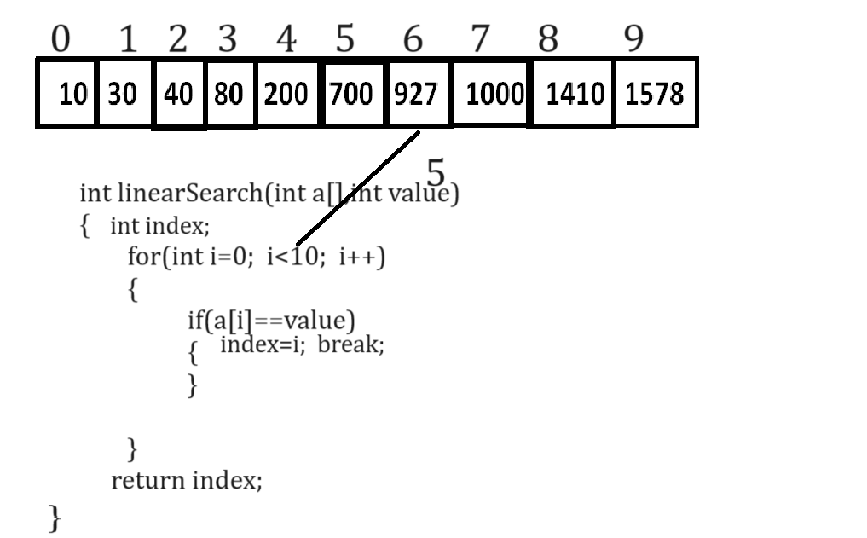
Suppose consider if your n is 10 then how many processors operation is there
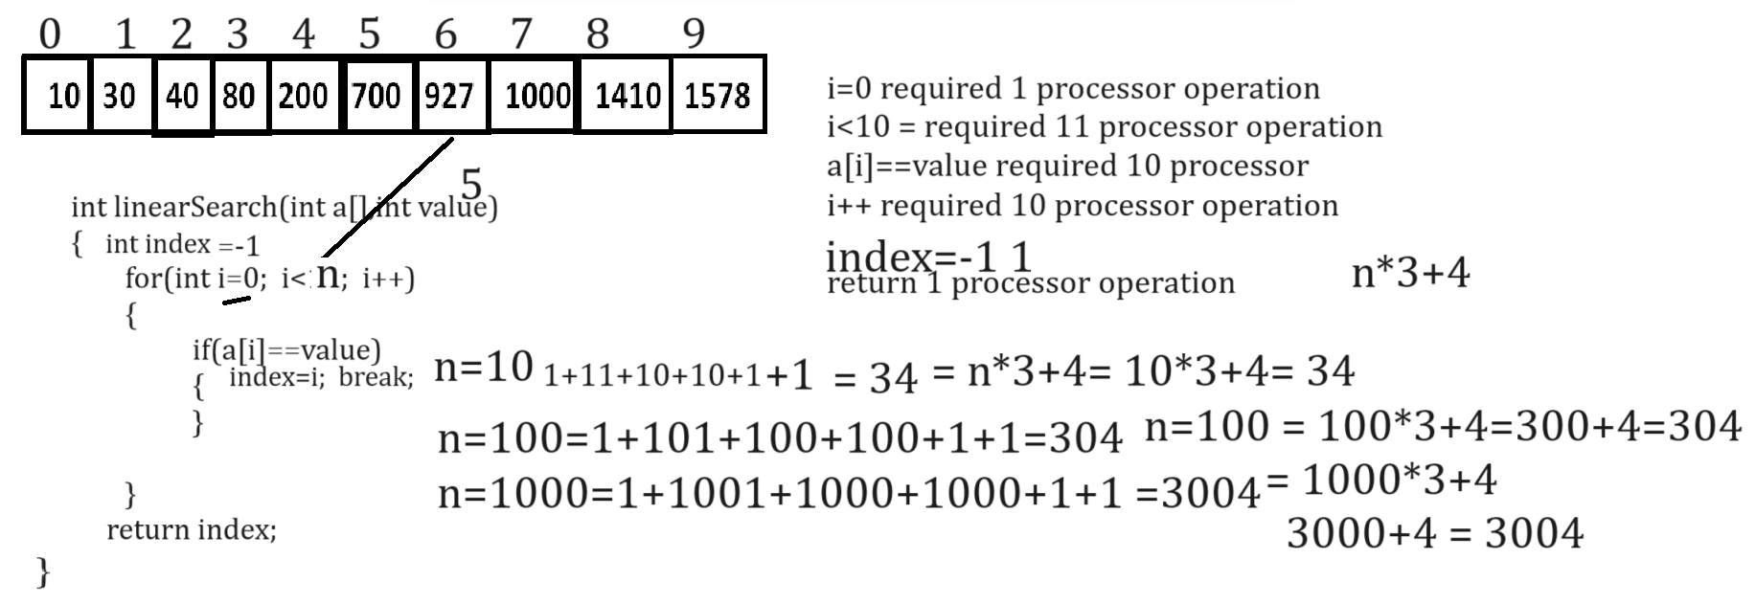
If we think about above code and if we consider our n=10 and value=5 then our code required following processor operations
index=-1 required 1 processor, i=0 required 1 processor operation, i<n required 11 processor operation , if(a[i]==value) required 10 processor operation, i++ required 10 processor operation and return 1 processor operation
so, we have total processor operation is 1 +1+11+10+10+1 =34
Means here we can say if you n=10 then you required total 34 processor operation
If you vary n value means if your n=100 then you required to 304 processor operation mention in above diagram and if your n=1000 then you required to total 3004 processor operation
so, we can say as per our above code linear search algorithm required
n*3+4 processor
e.g. n=10 then 10*3+4 = 34
n=100 then 100*3+4 = 304
n=1000 then 1000*3+4 = 3004
Means here we can say processor operation is dependent on n value or input value.
Binary Search:
_____________________________________________________________________________________
Binary search is searching technique but it is work only on sorted array
And if we think about binary search then your array divide in two parts and find the middle element of array and search value compare with middle element of array and if search value match with middle element then return its index and if search value is less than middle element of array then search value at left hand side of array and if search value is greater than middle element of array then search value at right hand side of array.
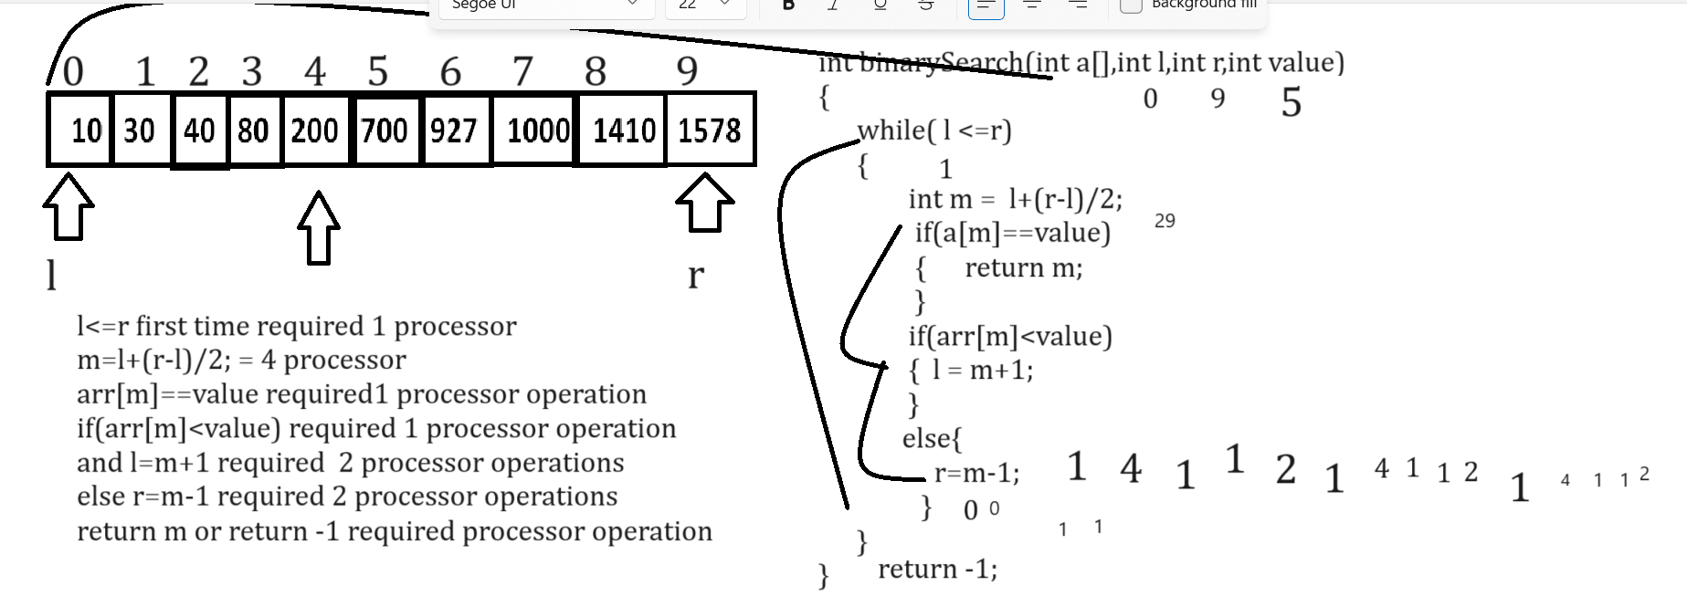

Q. What is Time Complexity?
_____________________________________________________________________________________
Time complexity is mathematical function
Q. what is function?
_____________________________________________________________________________________
Function is like as box which accepts some input and process on it and generates output
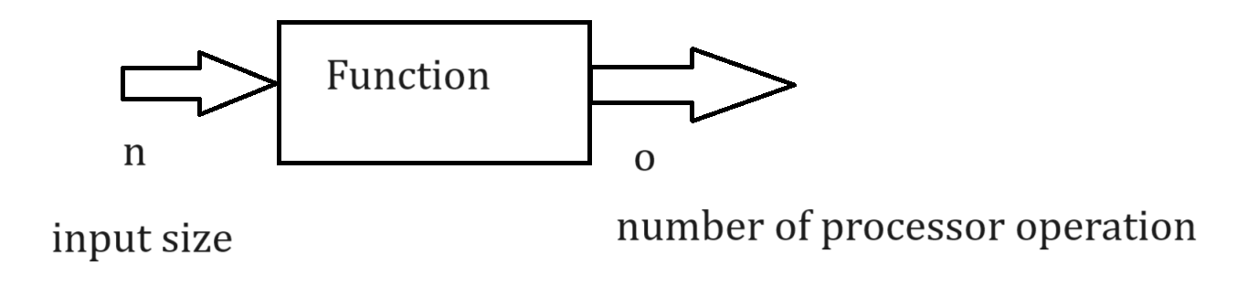
Here n is input size and o is number of processor operation
So, the time complexity is denoted by t and input is denoted by n, so it represents like as t(n)
If we think about previously mention input size and calculate its processor operation, we represent it by using single mathematical function
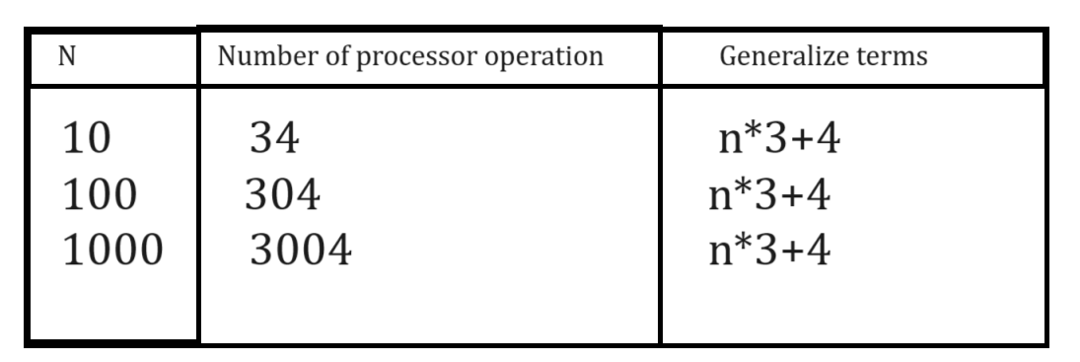
If we convert above generalize terms in mathematically then it looks like as
T (n)=3n+4

Suppose consider we have following code, and we want to calculate its time complexity

int myFun(int x)
{ x=x+1;
return x*5;
}
If we think about above code, we x=x+1 it required 2 processor operation and return x*5 it required 2 processor operation means it required 4 processor operations, so the complexity of above code is
t(4) means this code cannot change the processor operation or processor operation on above code is not dependent on input size it is fix so we can say it is constant time complexity so it is t(1)
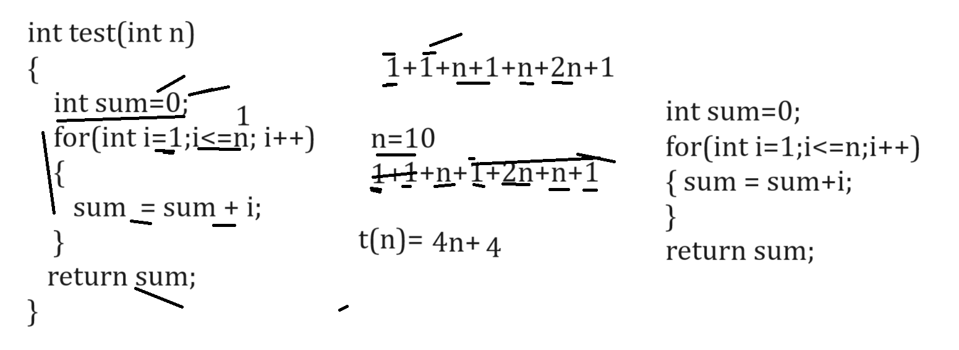

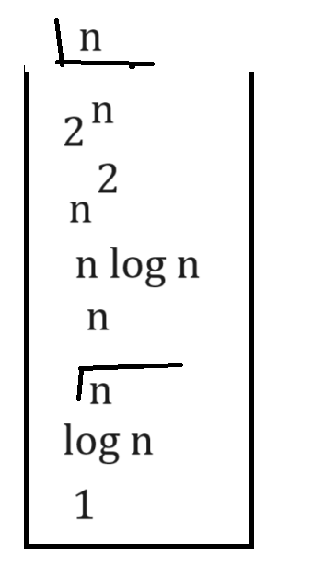

Function recursion
_____________________________________________________________________________________
Function recursion means function call itself again and again called as function recursion.
In short, we can say if we call the function from its own definition called as function recursion.

Syntax:
return type functionname(datatype variablename)
{
if(condition)
{ write here logics
functionname(arguments)
}
else{
}
}
Example: WAP to print five times good morning using a function recursion.

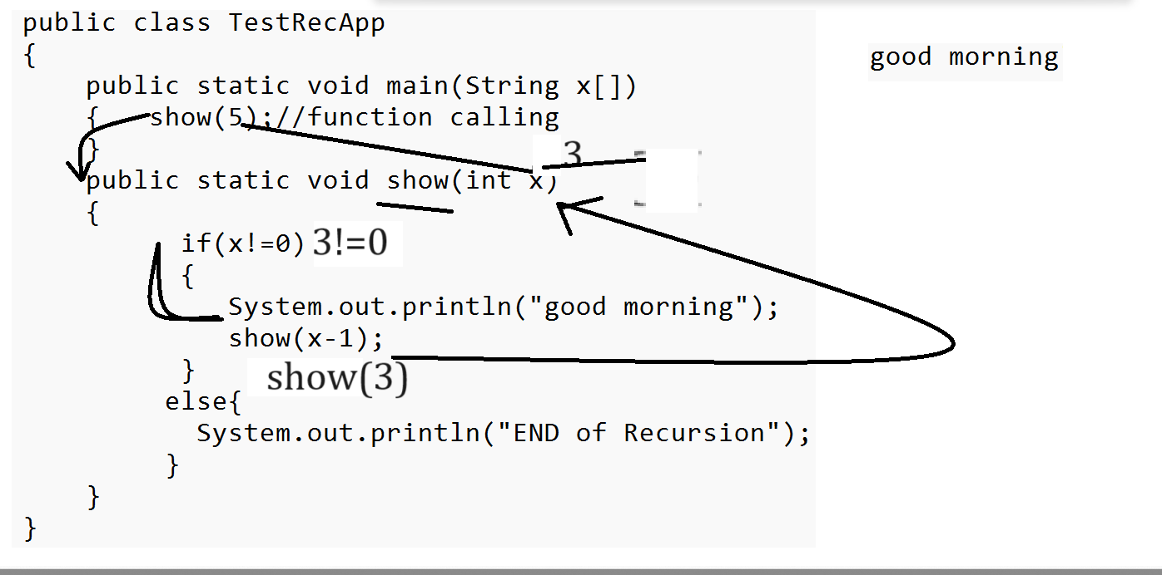

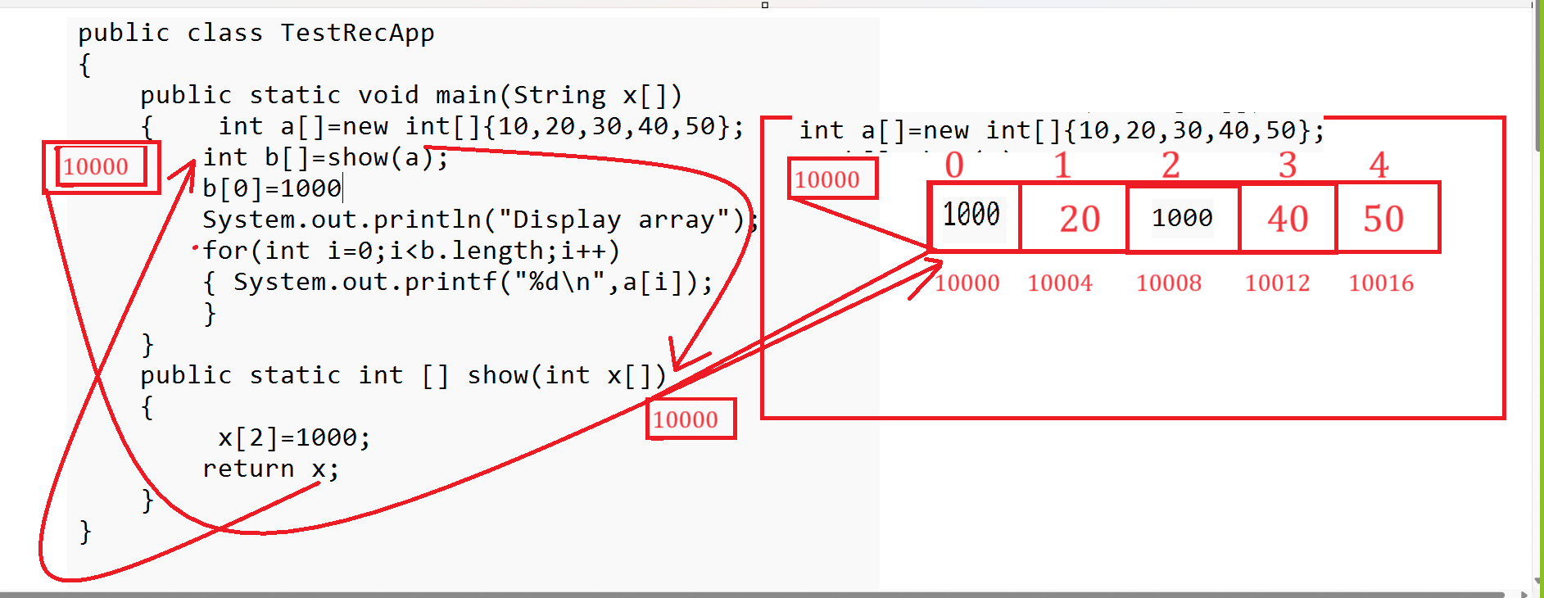
Output: 1000 20 1000 40 50

